 | SR UNIVERSITY  Campus Warangal
 | Program: II - B. Tech (CS& AI) Batch:
 | Name: G. sriharshitha Reg. No:2503A54018
 | Department: Computer Science and AI Semester: I
 | AI Assisted Coding-Assignment Date: 18-09-26

ASSIGNMENT 1 – Debugging Input Validation
Original code & Output:
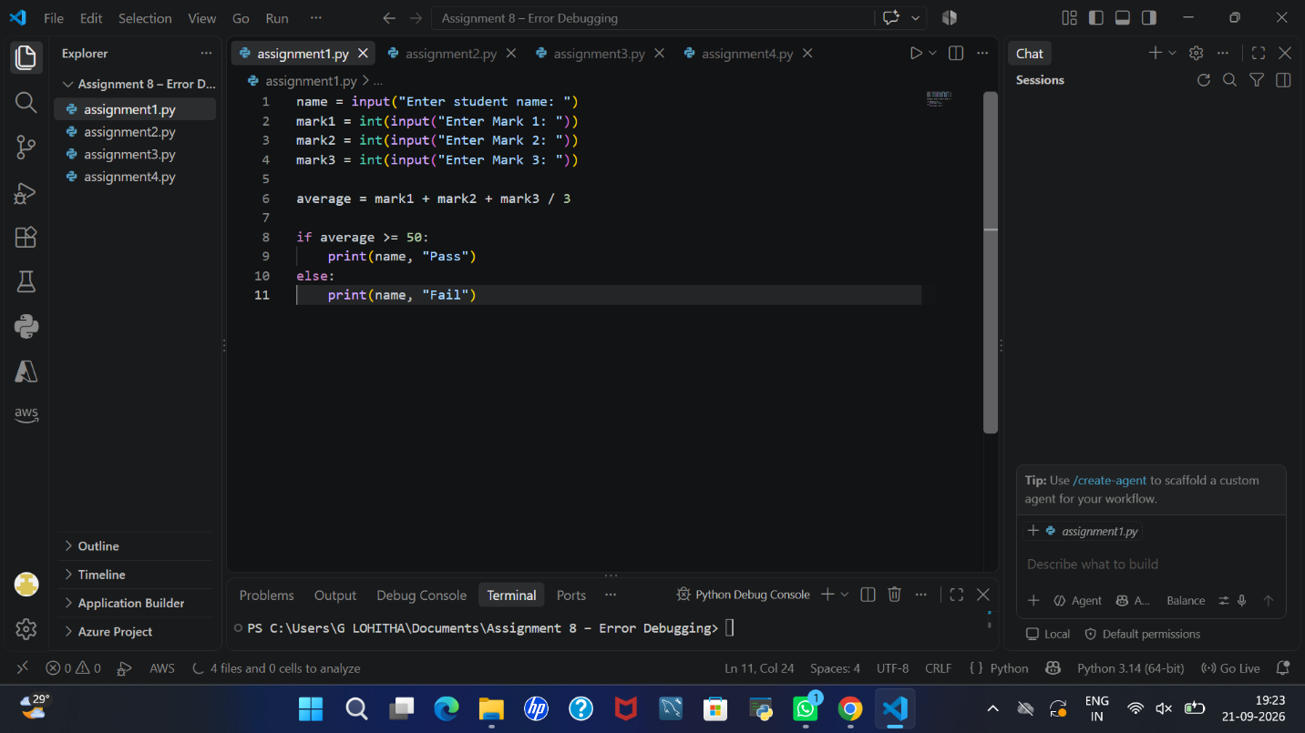
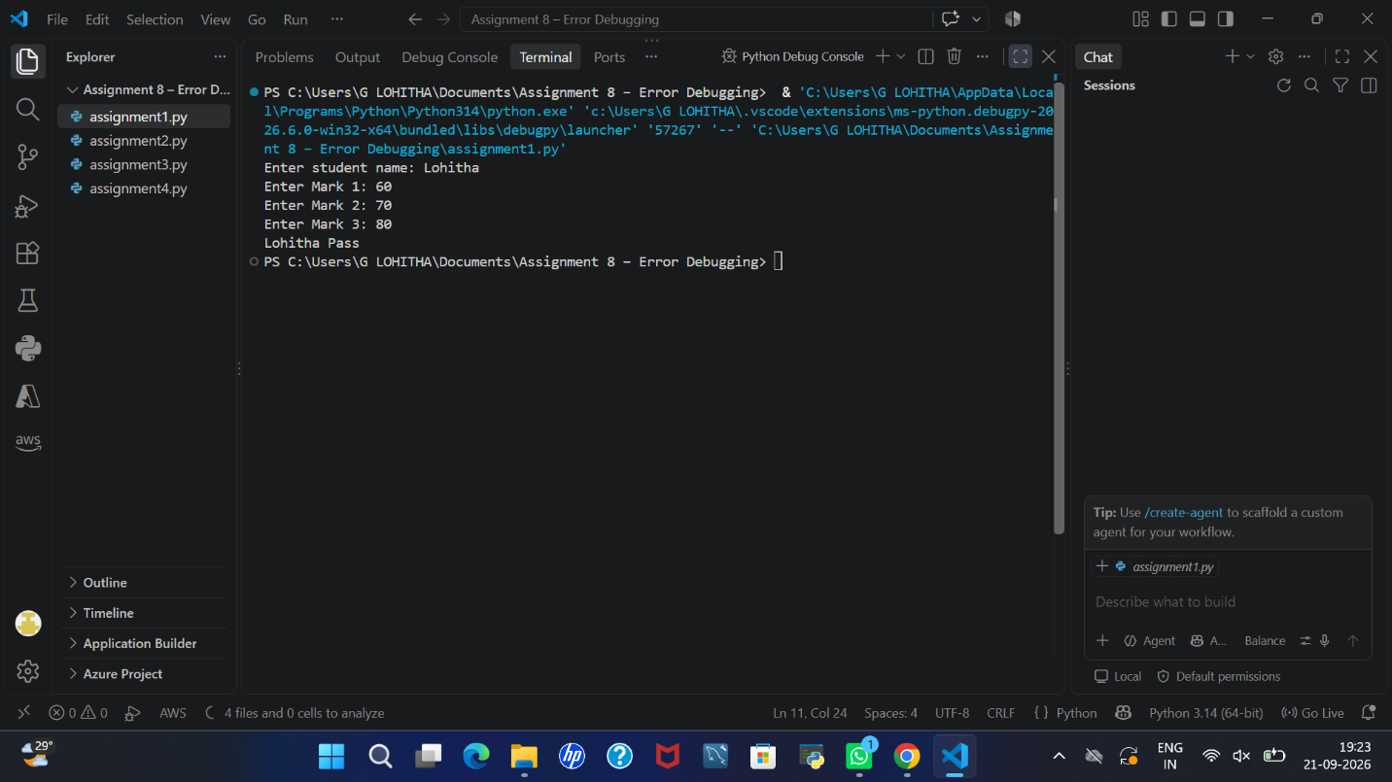
- Identify at Least 3 Problems:
• Incorrect average calculation: The average formula does not use parentheses correctly. Due to operator precedence, the program may calculate the average incorrectly.
• Missing mark validation: The program does not properly check whether the entered marks are within the valid range of 0 to 100.
• Non-numeric input error: If the user enters text instead of a number, the program may raise a ValueError and stop running.
- Use AI to explain the bugs before asking for a complete rewrite.

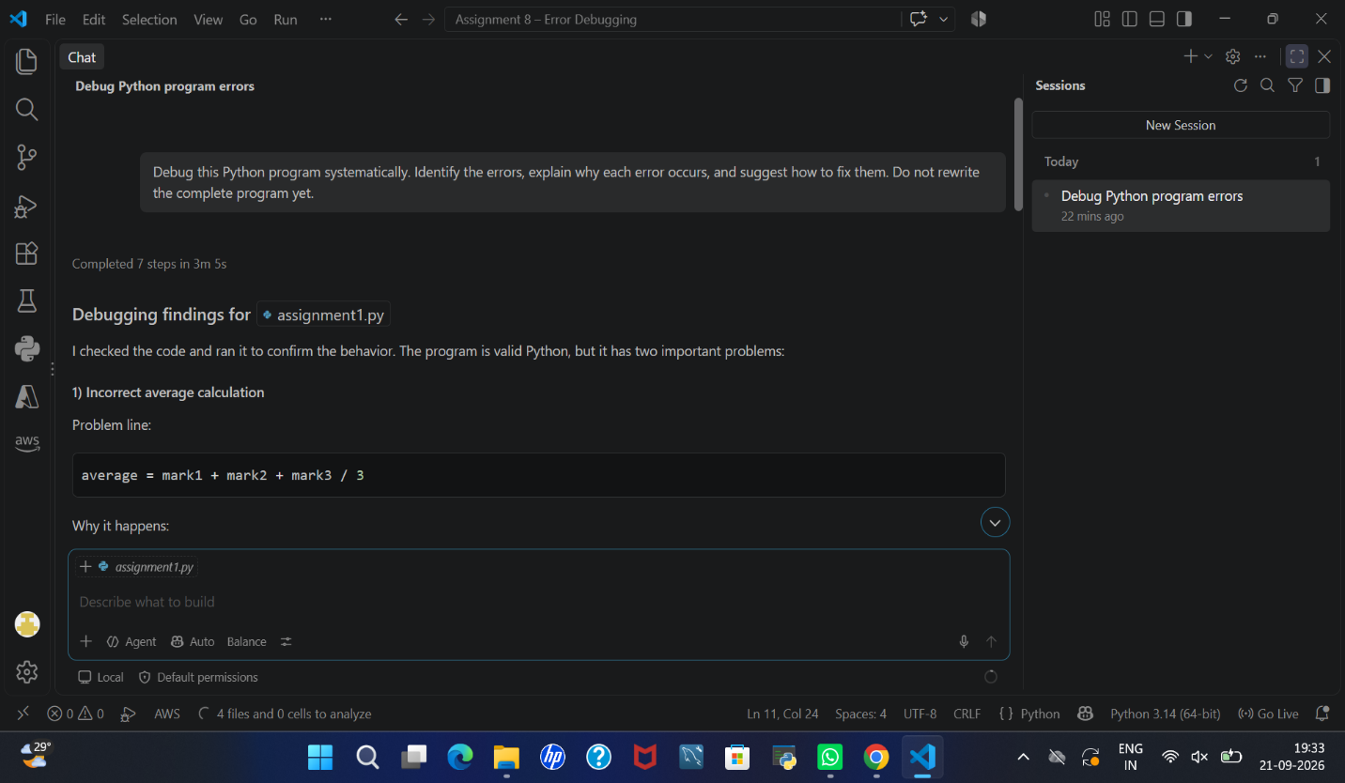
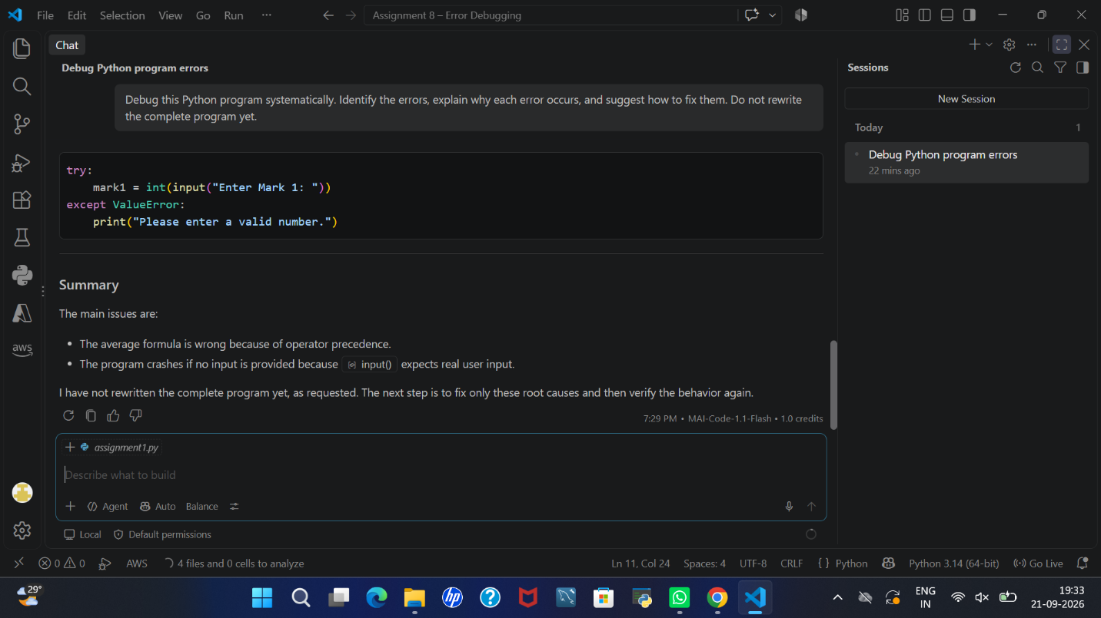

3.Correct the program.
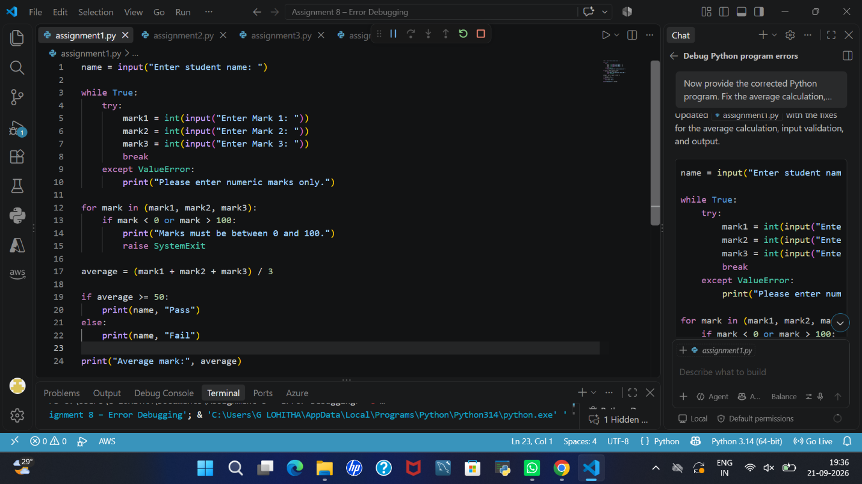

4.Validate marks from 0–100 and handle non-numeric input.
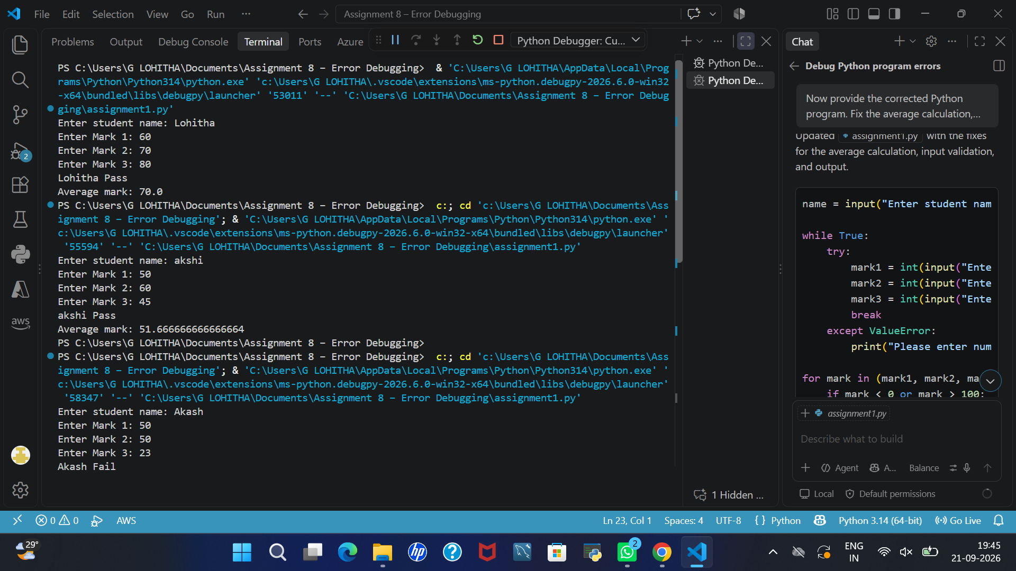
5. Test at least five inputs.
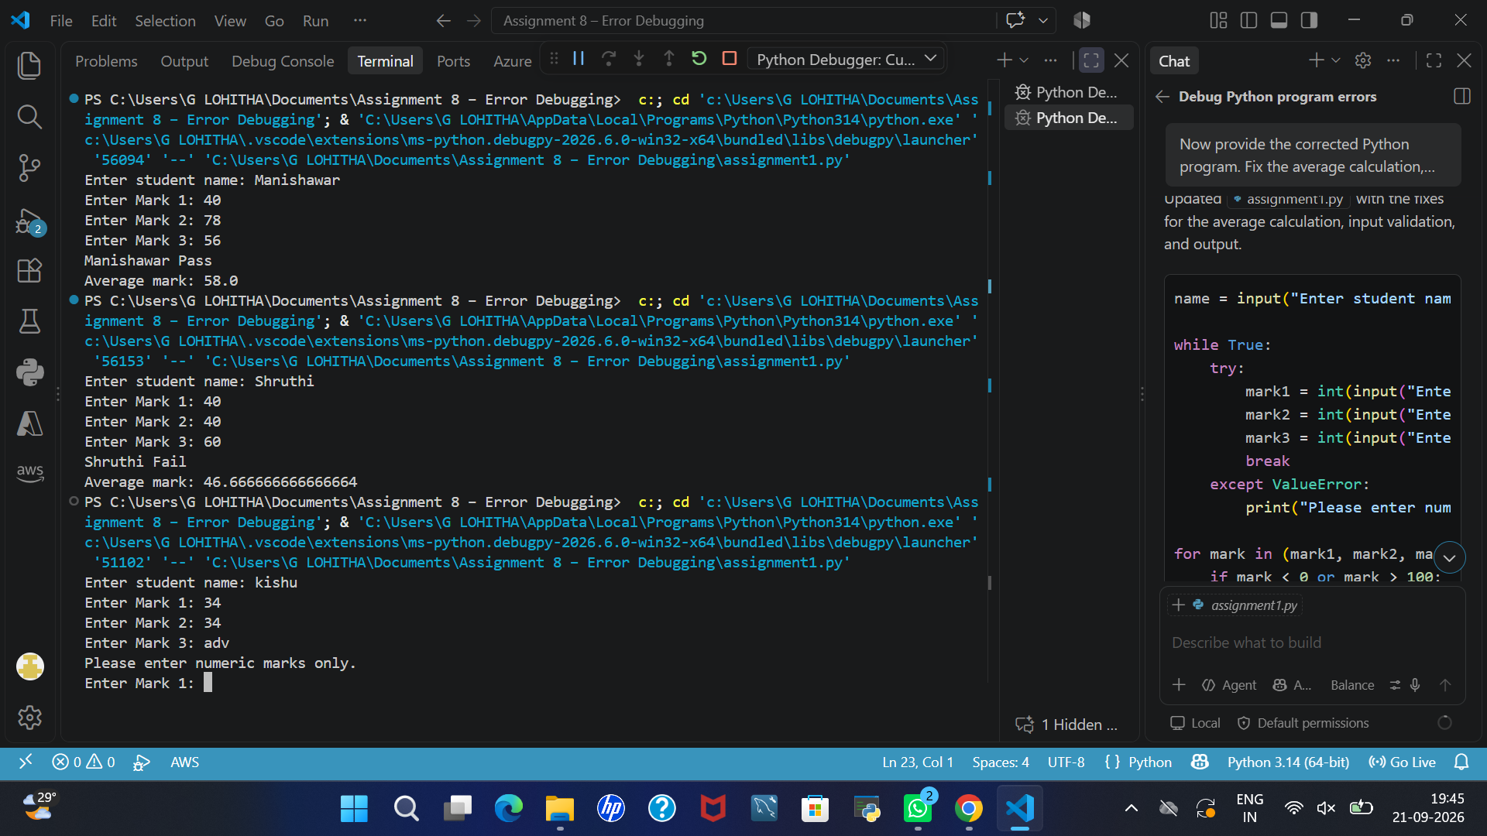
6.Explain which AI suggestions were accepted or rejected.
Accepted suggestions
- Correcting the average formula using parentheses
- Validating marks within the range of 0 to 100
- Handling non-numeric input using try-except.
- Displaying the average mark.
Rejected suggestions: No AI suggestions were rejected.
ASSIGNMENT 2 – Debugging Loops and Conditions
Original code & Output:

n = int(input("Enter n: "))
total = 0
for i in range(1, n):
if i % 2 == 1:
total = total + i
print("Sum of even numbers =", total)
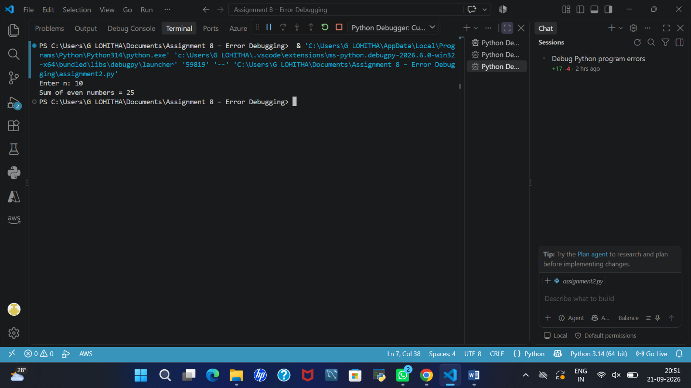
1.Find the logical errors.
After examining the original program, I identified the following logical errors:
- Incorrect loop range: The program uses range(1, n), which excludes the final value n from the loop.
- Incorrect condition: The condition i % 2 == 1 checks for odd numbers instead of even numbers.
- Incorrect sum: Due to the incorrect loop range and condition, the program does not calculate the required sum of even numbers.
These errors cause the program to produce an incorrect result.
2.Use AI to explain why the output is wrong.
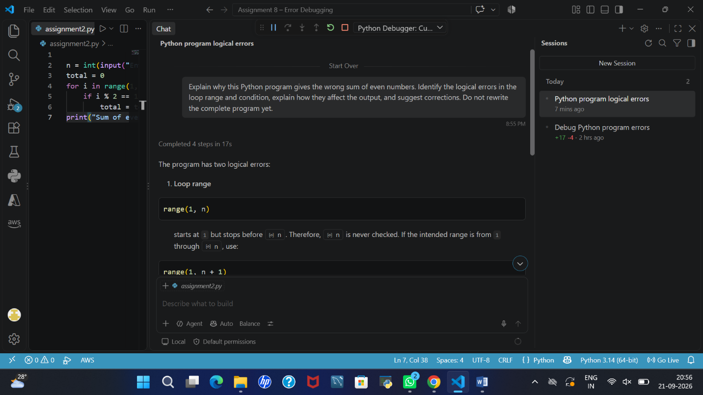
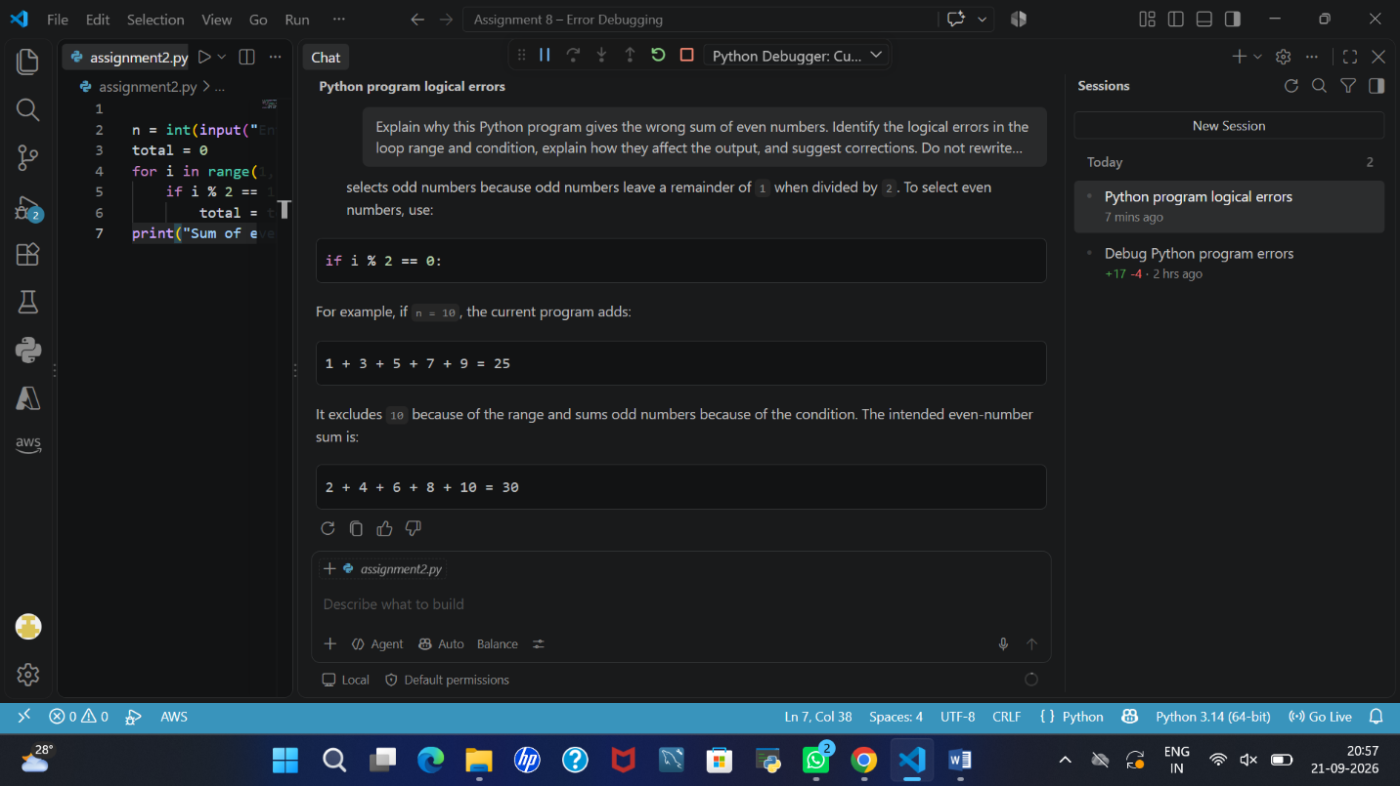
3.Correct the loop and condition.

n = int(input("Enter n: "))
total = 0

for i in range(1, n + 1):
if i % 2 == 0:
total = total + i

print("Sum of even numbers =", total)
4.Test n = 10, n = 20 and n = 1.
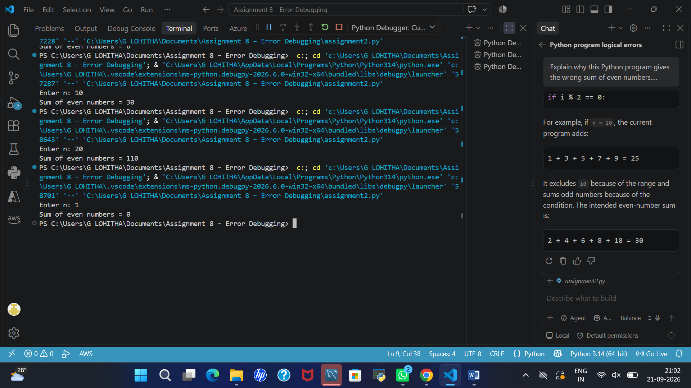
5.Verify the results manually.

Manual Verification
I verified the program results manually by adding the even numbers from 1 to the given value of n. The manually calculated sums matched the program output.
Input (n) | Manual calculation | Expected sum
10 | 2 + 4 + 6 + 8 + 10 | 30
20 | 2 + 4 + 6 + 8 + 10 + 12 + 14 + 16 + 18 + 20 | 110
1 | No even numbers between 1 and 1 | 0
Conclusion: The corrected program produces the expected results for all three test cases.
6.Write a short debugging explanation.
The original program produced the wrong sum because the loop range range(1, n) excluded the final number n, and the condition i % 2 == 1 selected odd numbers instead of even numbers. I corrected the loop to range(1, n + 1) and changed the condition to i % 2 == 0. After correcting these errors, the program calculated the sum of even numbers correctly for the test cases.
ASSIGNMENT 3 – Debugging Functions and Return Values
Original code & Output: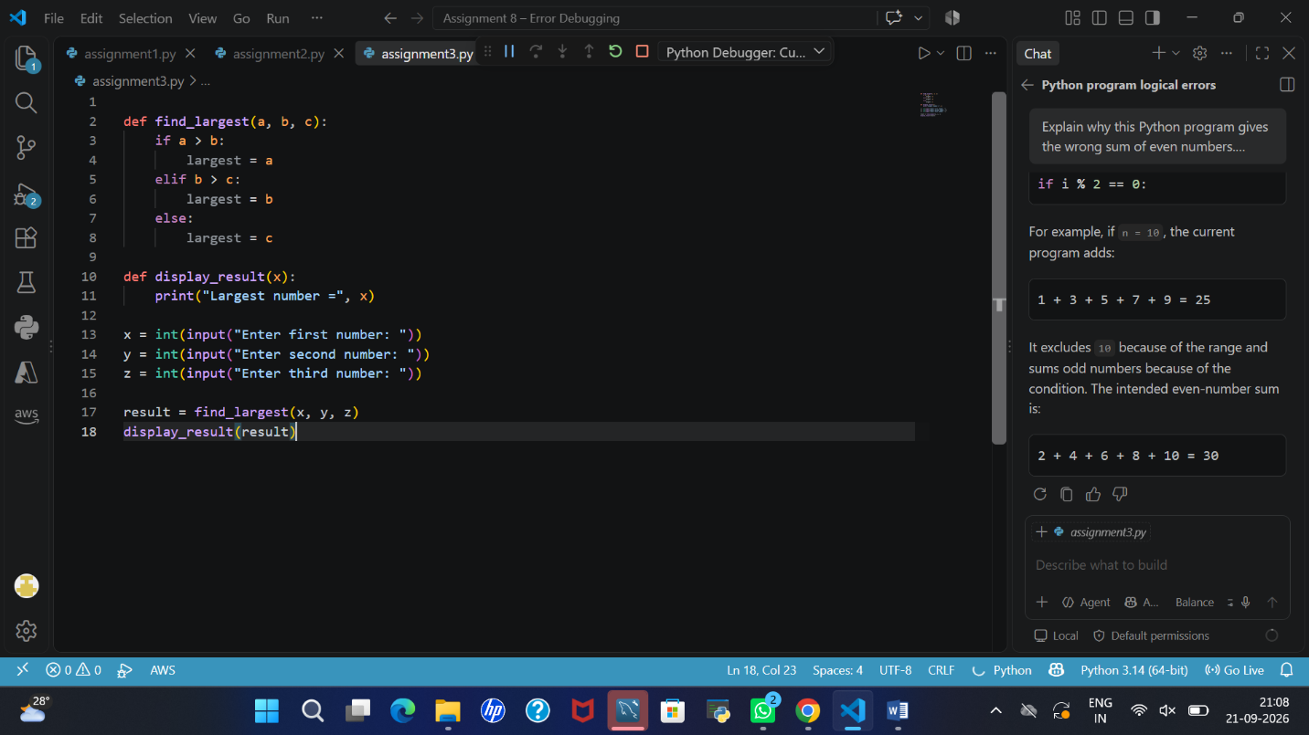
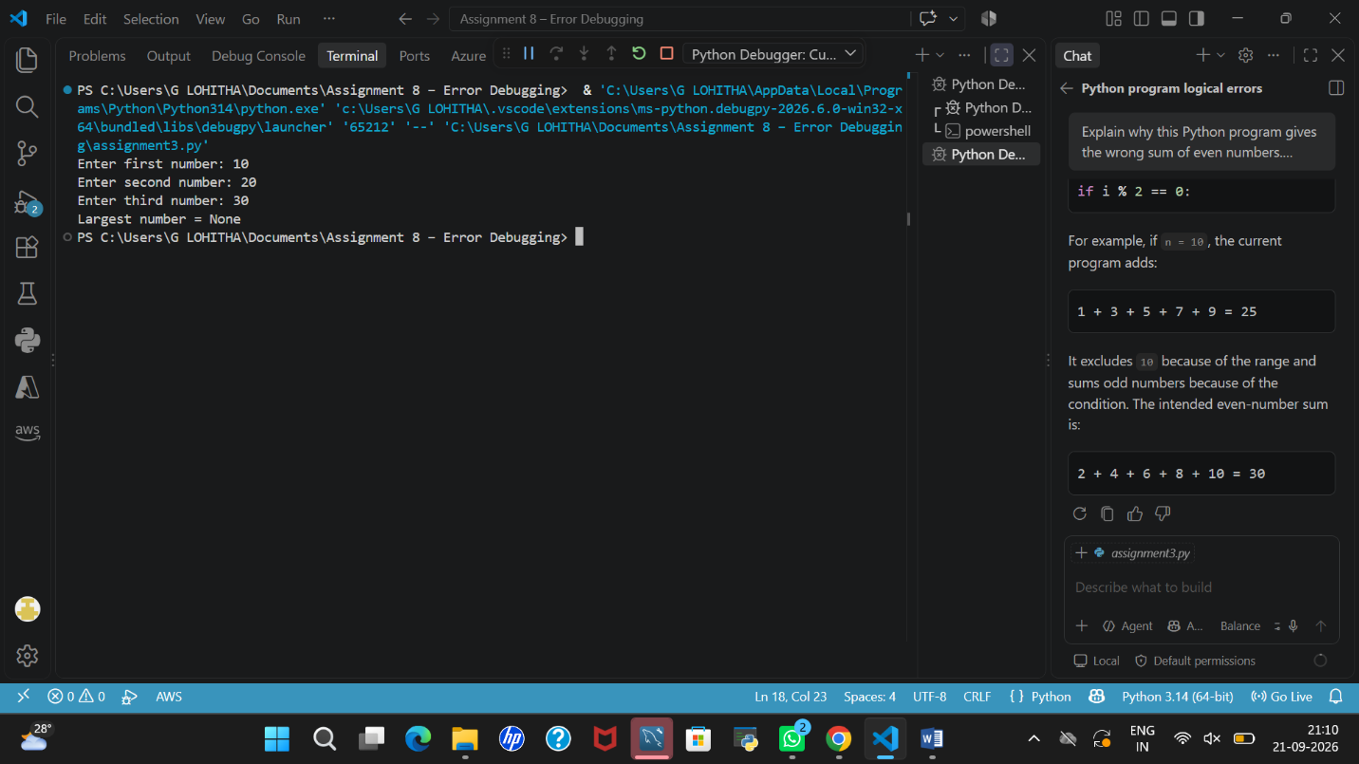

1.Identify the Function-Related Bug
The main bug is that the find_largest() function does not contain a return statement. Although it calculates the variable largest, it does not send that value back to the calling statement. Therefore, result receives None, and the program displays Largest number = None.
Another logical error is that the conditions do not correctly compare all three numbers in every input combination. For example, when the first number is greater than the second number but the third number is larger than both, the function may still select the first number
2.Check Input Combinations and Boundary Cases
Test case | Inputs (a, b, c) | Expected largest number
1 | (10, 20, 30) | 30
2 | (50, 20, 10) | 50
3 | (20, 50, 30) | 50
4 | (25, 25, 10) | 25
3.Use AI to trace function execution.
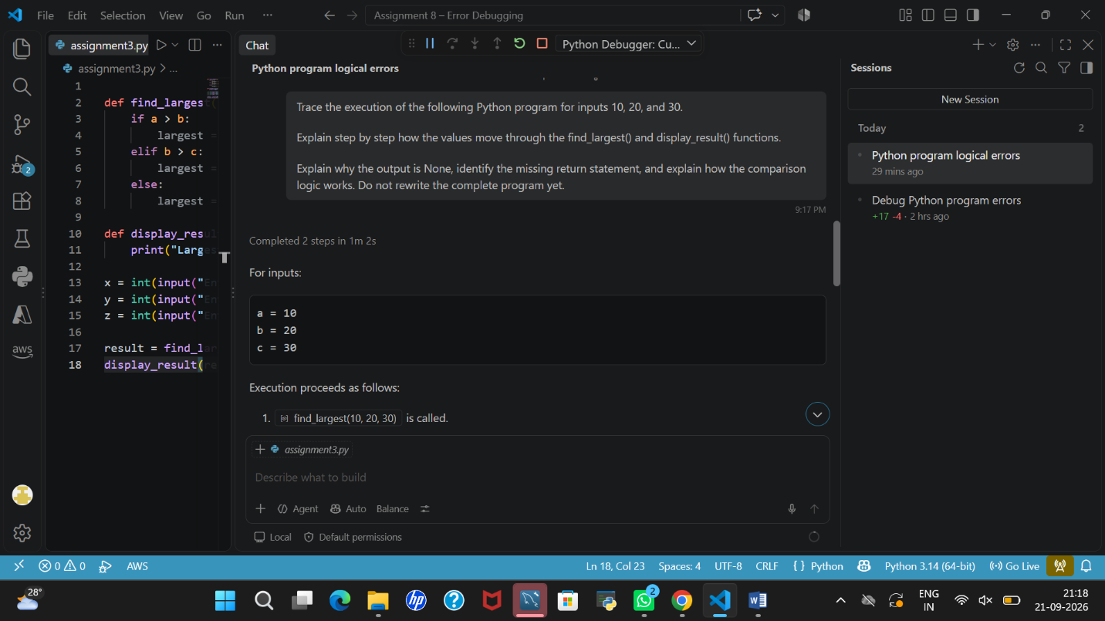
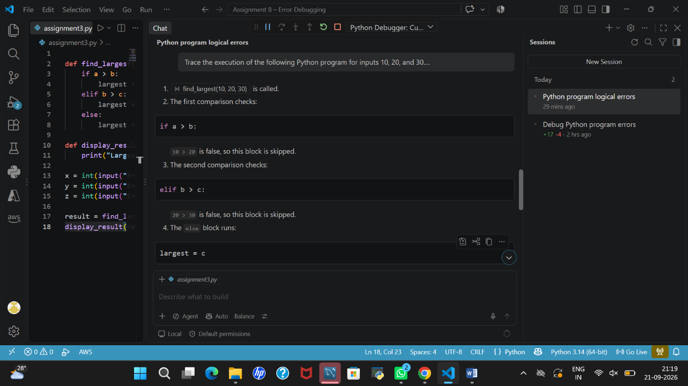
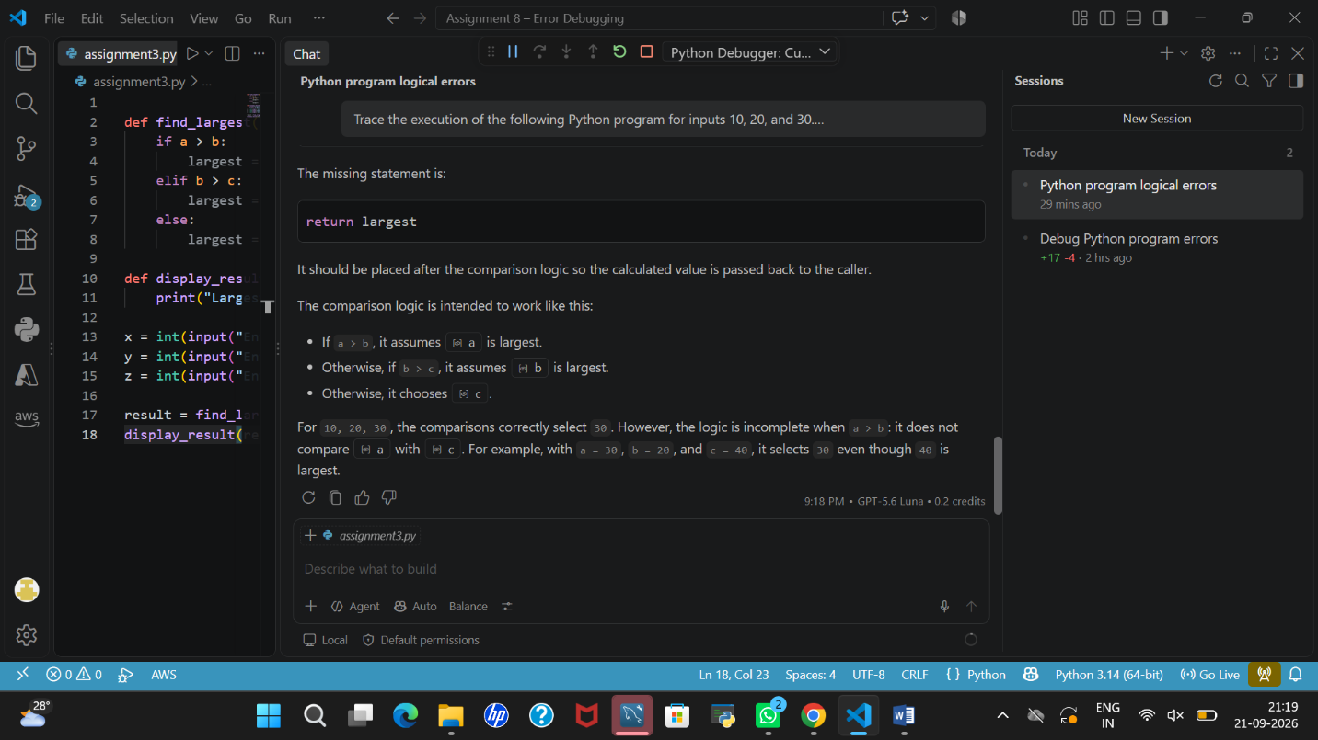
4.Fix the program.
I corrected the program by fixing the comparison conditions and adding the return largest statement. The function now returns the largest number to the calling part of the program. I tested the corrected program using the required input combinations, including cases where the largest number appears in different positions and where two numbers are equal. The program displayed the expected results.
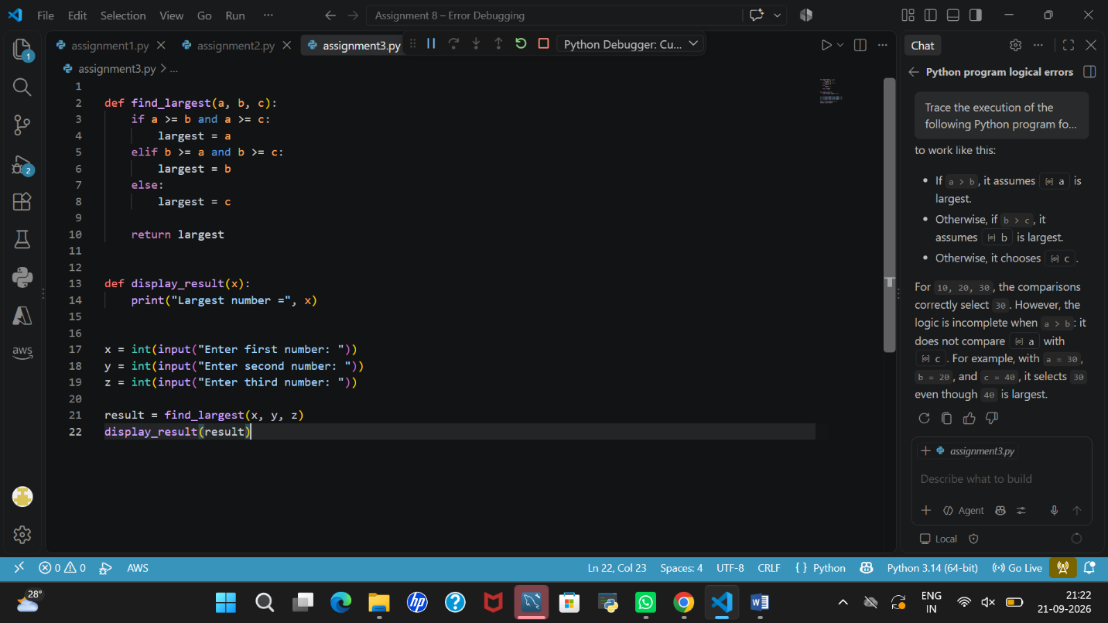
5.Test (10,20,30), (50,20,10), (20,50,30) and (25,25,10).
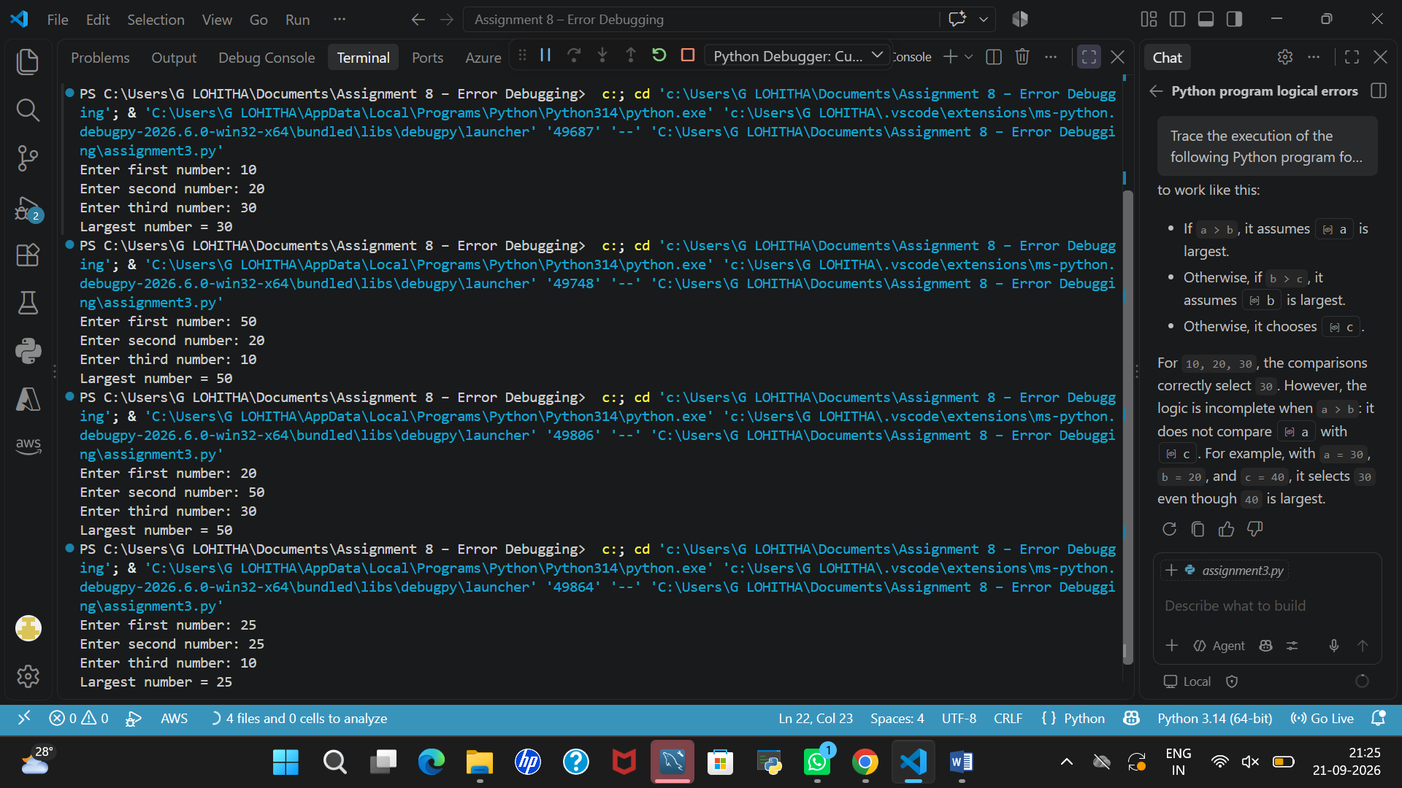
6.Explain the importance of return statements.
A return statement is important because it sends a result from a function back to the part of the program that called it. Without a return statement, a Python function returns None by default. In our program, return largest sends the largest number back to the main program, allowing it to be stored in the result variable and displayed correctly. Therefore, return statements help functions provide results that can be used in other parts of a program.
ASSIGNMENT 4 – Debugging a Student Result Program
Original code & Output:
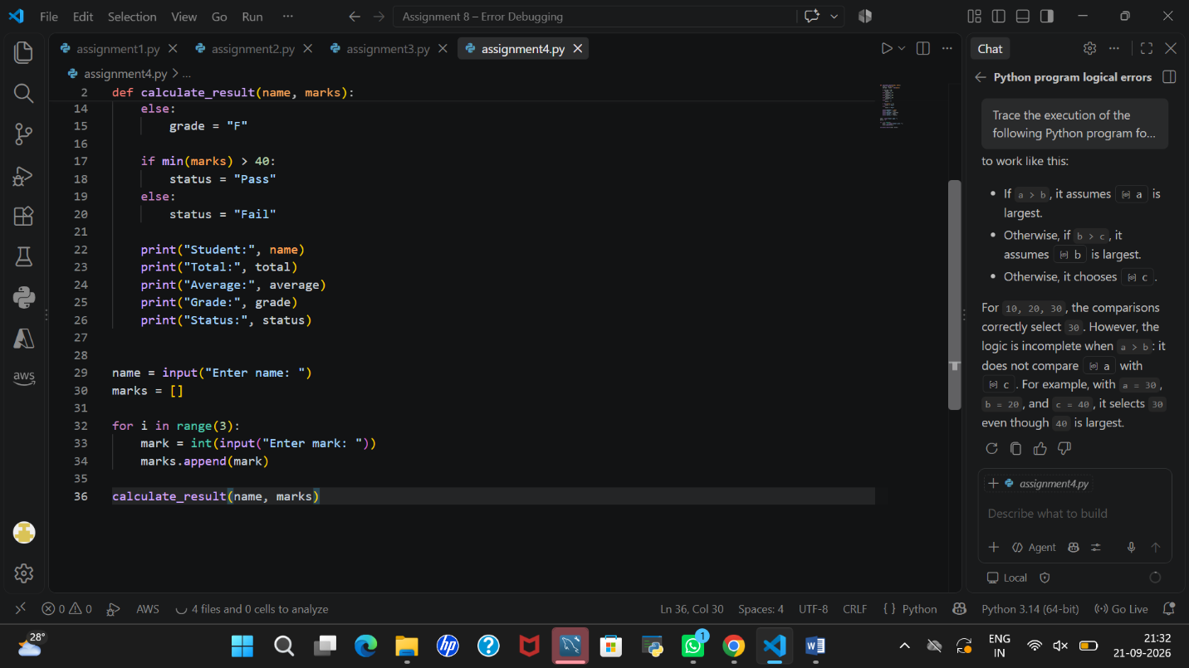
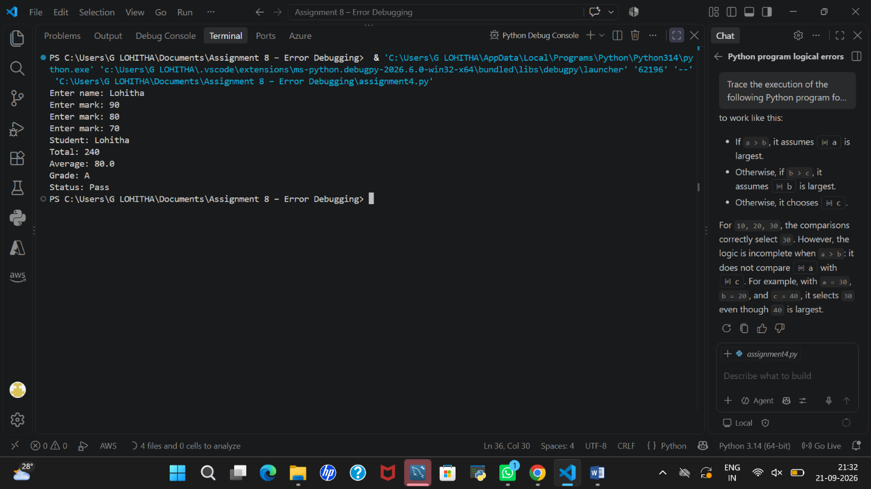
1.Identify at least 5 bugs or boundary-condition problems
No. | Bug / problem | Why it is a problem
1 | Grade condition uses average > 90 | A student with exactly 90 does not receive A+.
2 | Grade conditions use strict > comparisons | Students with exactly 75, 60, or 50 may be assigned the lower grade than intended at the boundary.
3 | Pass condition uses min(marks) > 40 | A mark of exactly 40 is treated as a fail.
4 | No mark range validation | The program accepts marks below 0 or above 100.
5 | No non-numeric input handling | Entering text instead of a number causes a ValueError.
2.Use AI for systematic analysis.
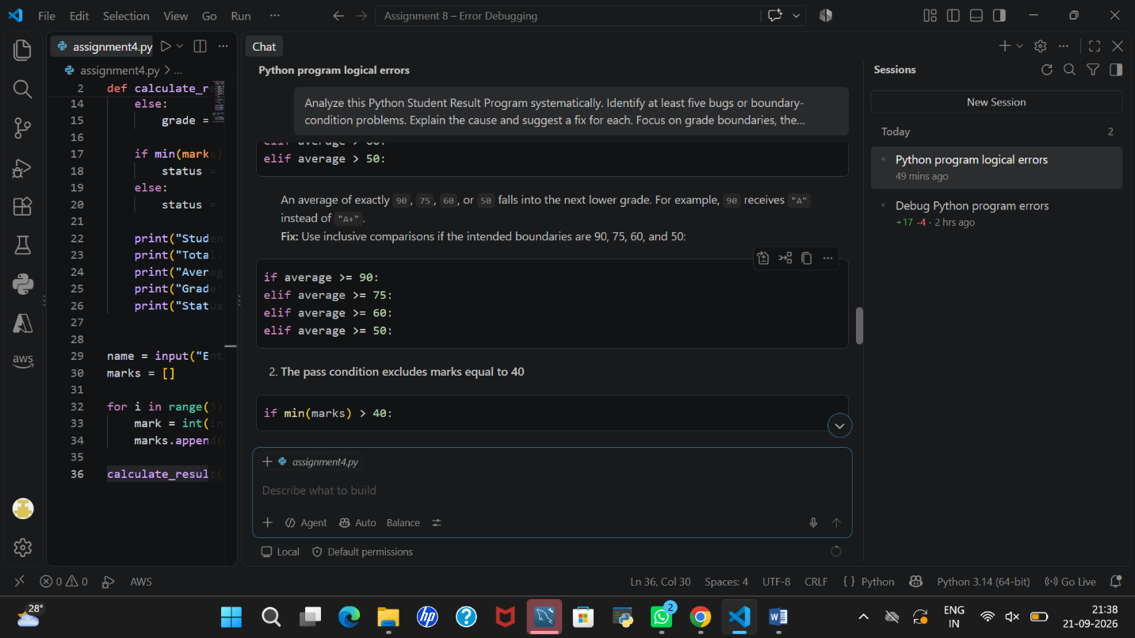
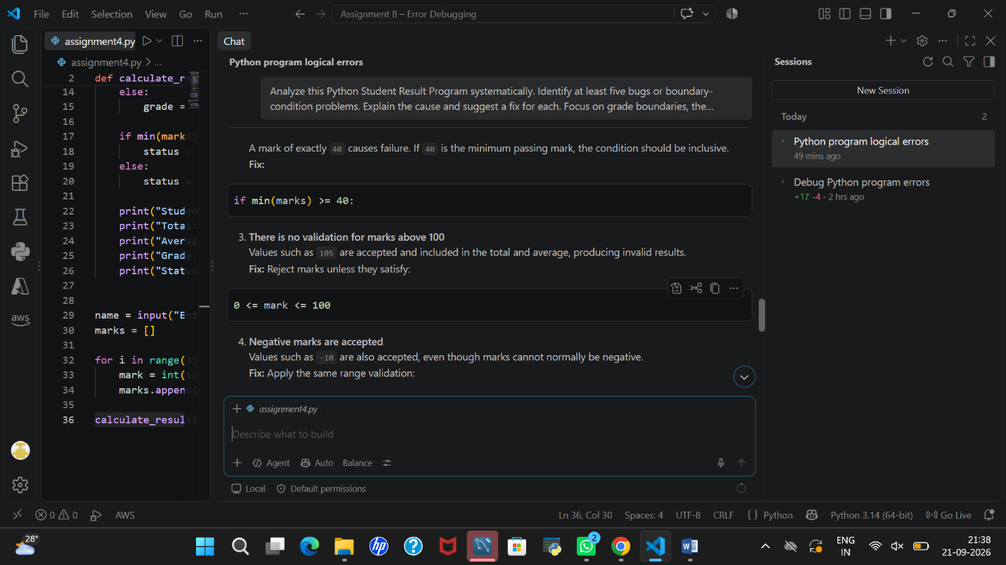
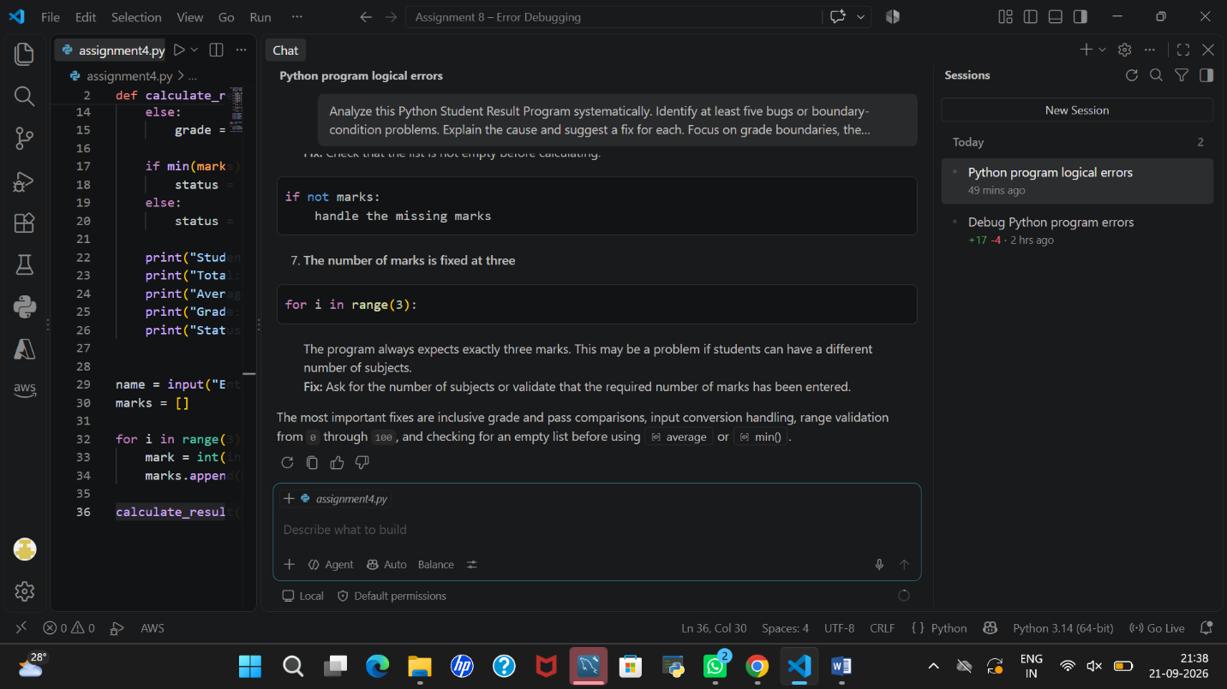
3.Create a bug report

Bug Report – Debugging a Student Result Program
Program Name: Student Result Program
Objective: To identify and correct logical errors, boundary-condition problems, and input validation issues in the original program.
Bug No. | Bug Identified | Cause of the Bug | Proposed Fix
1 | Incorrect A+ grade boundary | The condition uses average > 90, so an average of exactly 90 does not receive A+. | Change it to average >= 90.
2 | Incorrect A grade boundary | The condition uses average > 75, so an average of exactly 75 is assigned a lower grade. | Change it to average >= 75.
3 | Incorrect B and C grade boundaries | The conditions use strict greater-than comparisons for 60 and 50. | Use average >= 60 and average >= 50.
4 | Incorrect pass condition | The program uses min(marks) > 40, which treats a mark of exactly 40 as a fail. | Change it to min(marks) >= 40.
5 | Marks outside the valid range are accepted | The program does not check whether marks are between 0 and 100. | Validate each mark using 0 <= mark <= 100.
6 | Non-numeric input causes an error | The program converts input directly using int() without handling invalid text. | Use try and except ValueError to handle non-numeric input.
7 | Empty marks list is not handled | Calculating the average with an empty list causes division by zero. | Check whether the list is empty before calculating the average.
Conclusion: The bug report helped identify the main logical and input-related problems in the original program. These issues can be corrected by adjusting the conditions, validating marks, handling invalid input, and checking for an empty marks list.
4.Correct the Program

def calculate_result(name, marks):
if not marks:
print("Error: Marks list cannot be empty.")
return

total = sum(marks)
average = total / len(marks)

if average >= 90:
grade = "A+"
elif average >= 75:
grade = "A"
elif average >= 60:
grade = "B"
elif average >= 50:
grade = "C"
else:
grade = "F"

if min(marks) >= 40:
status = "Pass"
else:
status = "Fail"

print("Student:", name)
print("Total:", total)
print("Average:", average)
print("Grade:", grade)
print("Status:", status)

name = input("Enter name: ")
marks = []

for i in range(3):
while True:
try:
mark = int(input(f"Enter mark {i + 1}: "))

if 0 <= mark <= 100:
marks.append(mark)
break
else:
print("Marks must be between 0 and 100.")

except ValueError:
print("Please enter a valid numeric mark.")

calculate_result(name, marks)
5.Validate marks from 0–100 and handle non-numeric input.
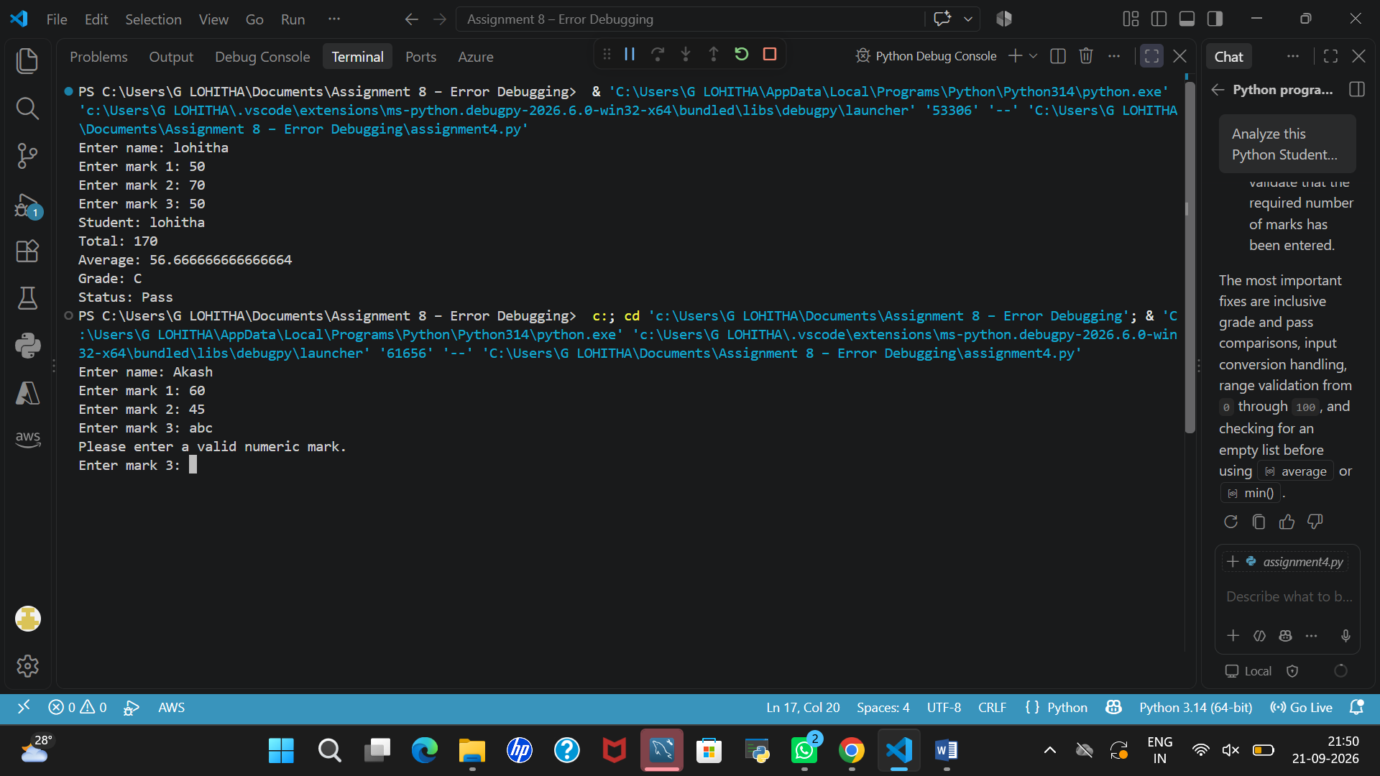
6. Verify grade boundaries
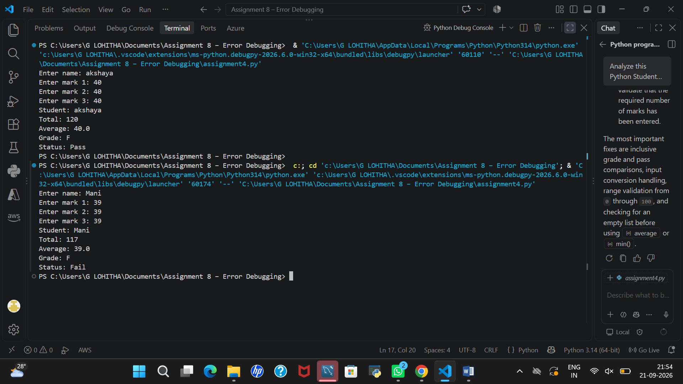
The grade boundaries were verified by testing marks at 90, 75, 60, 50, 40, and 39. The program displayed the expected grades and correctly identified the pass/fail status. Therefore, the corrected program handles the grade boundaries as expected.
7.Test at least 8 cases.
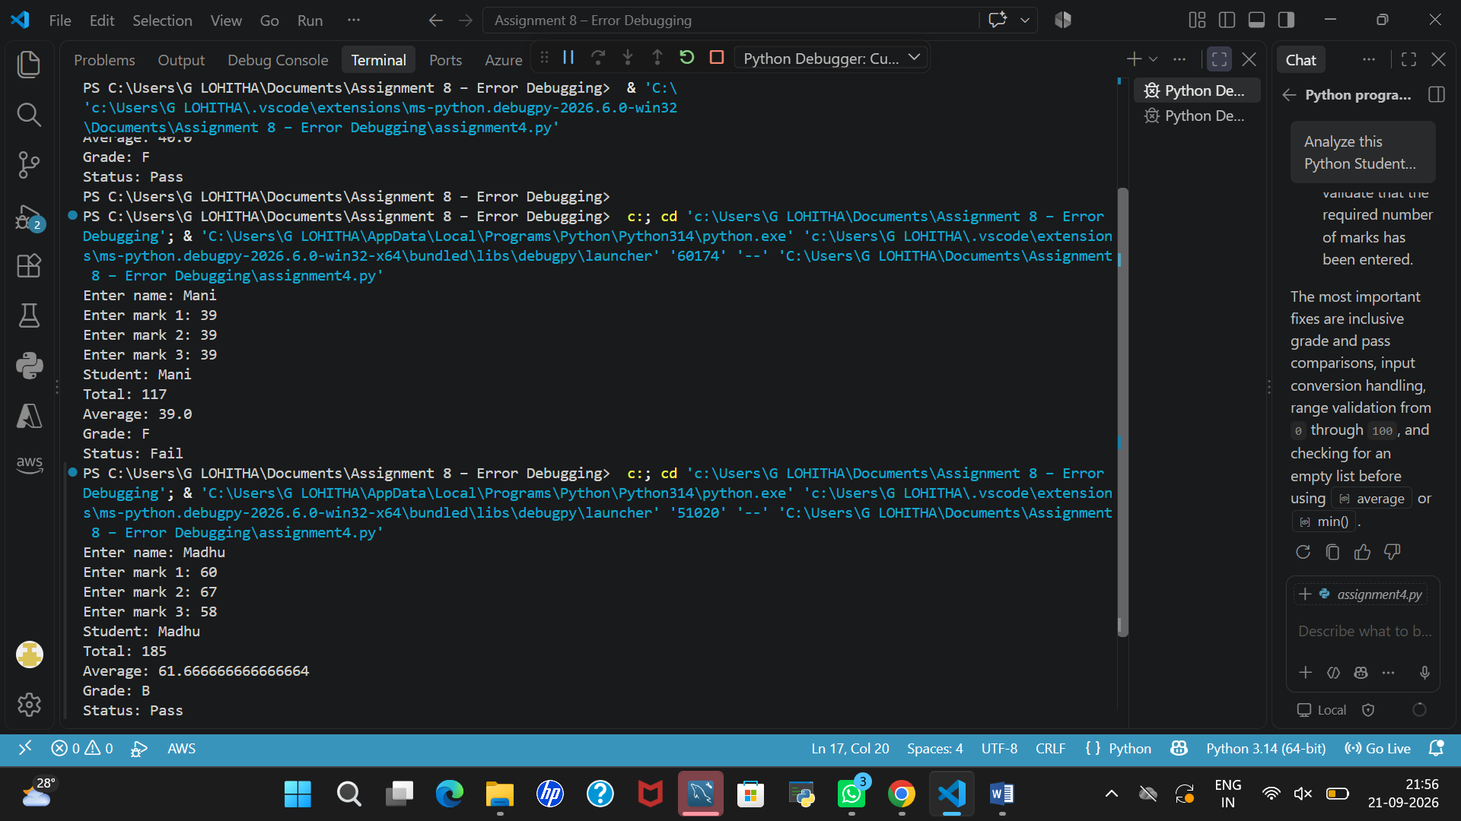
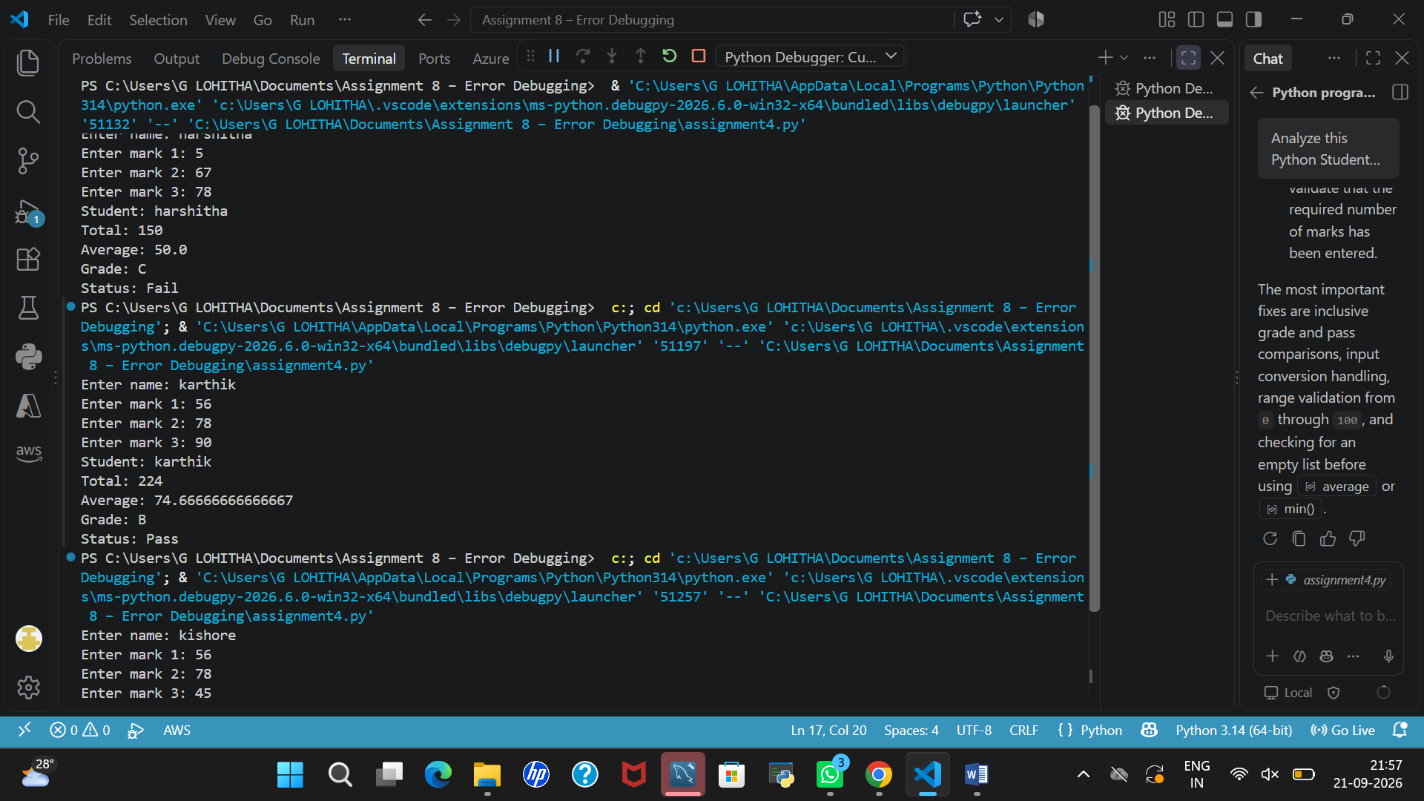
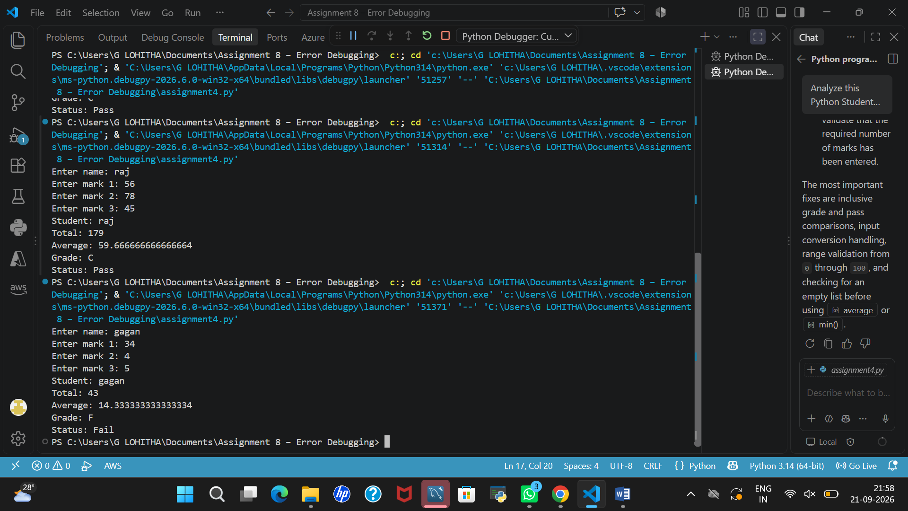
8.Compare original and corrected versions.
Original version | Corrected version
Uses > for grade boundaries, so exact boundary marks may receive the wrong grade. | Uses >= to handle grade boundaries correctly.
Uses min(marks) > 40, so a mark of exactly 40 is considered Fail. | Uses min(marks) >= 40, so a mark of 40 is considered Pass.
Does not validate whether marks are between 0 and 100. | Accepts marks only between 0 and 100.
Does not handle non-numeric input, which can cause a ValueError. | Uses try-except to handle non-numeric input.
Does not check whether the marks list is empty, which can cause an error. | Checks for an empty marks list before calculating the average.
May produce incorrect grade results at boundary values. | Calculates the grade and pass/fail status according to the corrected conditions
9.Explain how AI helped.
AI helped me identify the errors in the original student result program, such as incorrect grade boundary conditions, improper pass/fail checking, and missing input validation. It suggested corrections using >= conditions, try-except for non-numeric input, and a check for an empty marks list. AI also helped me understand the errors and improve the program. Finally, I tested the corrected code with different marks, including boundary and invalid values, to verify that it worked as expected

